# Release Information

|  |  |
| --- | --- |
| *Release* | *3* |
| *Leader* | *Ryan* |
| *Git Repo* | *https://vancemi@atlas.ion.uwplatt.edu/bitbucket/scm/ise/1-nullreferenceexception.git* |

This iteration now allows the user to create new password protected chatrooms. The chatrooms have the command pattern implemented into them on the client side so that certain functions can be undone.

# Progress

|  |  |  |  |
| --- | --- | --- | --- |
| **Stories and spike solutions worked on during this release** | | | |
| **Story, Spike** | **Description** | **% Impl.** | **Notes, plan for completion** |
| *NRE-14* | *As a user I want to be able to direct message people so that I can talk privately* | *100* |  |
| *NRE-21* | *As a user I want to be able to switch themes so that my client can have more functionaility* | *100* |  |
| *NRE-13* | *As a user I want to be able to see previous messages from the chat room* | *50* | *We need to finish making network code and SQL queries.* |
| *NRE-25* | *As an administrator, I want to view helpful documentation on each command so that I can know what each command does* | *100* |  |
| *NRE-61* | *As an admin of a chat, I want to be able to change the password of my chatroom, so that I can update it with a more secure password.* | *0* | *We did not have enough time to include this functionality in our program.* |
| *NRE-59* | *As a user, I want to create a chatroom with a name and password, so that I can chat only with my friends.* | *50* | *We still need to finish up store procedures and queries to make this happen.* |
| *NRE-72* | *As a user, I want to be able to join a chatroom with a password, so that I can chat with my friends.* | *100* | *We did not have enough time to include this functionality in our program.* |
| *NRE-62* | *As a user, I want my chatroom text to scroll down as new messages appear, so that I can view them without navigating to them.* | *100* |  |
| *NRE-63* | *As a user, I want my view to be re-sizable, so that I can resize it for small or large screen.* | *0* | *We did not have enough time to include this functionality in our program.* |

|  |  |  |
| --- | --- | --- |
| **Accomplishments by engineer** | | |
| **Team Member** | **Total Time (hrs)** | **Stories, Spikes implemented** |
| *Ryan* | *12* | *NRE-14*  *NRE-13*  *NRE-25*  *NRE-59*  *NRE-72* |
| *Liam* | *13* | *NRE-14*  *NRE-13*  *NRE-61*  *NRE-59* |
| *Austin* | *14* | *NRE-63*  *NRE-21*  *NRE-62*  *NRE-72* |
| *Mitch* | *14* | *NRE-13*  *NRE-59*  *NRE-59*  *NRE-59* |
| TEAM TOTAL | ***53*** |  |

|  |  |
| --- | --- |
| **Document updates** | |
| **Document** | **Changes** |
| *README.txt* | *Changes to make instructions clearer.* |
|  |  |

# Issues

Document anything that is not decided yet and needs to be resolved at some point.

|  |  |  |  |  |
| --- | --- | --- | --- | --- |
| **Issue Number** | **Discovery**  **Date** | **Resolution**  **Date (Est.–Act.)** | **Responsible Person** | **Description (Prob / Resolution)** |
| 1 | 4/26 | Future | Ryan | Prob: When the user abruptly shuts down the program (for example, from task manager), the server still thinks that user is logged in and will not let that user log in again. Res: We need to “poke” the clients every so often to make sure the connection is live. |
| 2 | 4/24 | 4/24 | Ryan | Prob: Server code is difficult to debug with multithreading. Res: Added more class separation to make debugging one thread at a time easier. |
|  |  |  |  |  |
|  |  |  |  |  |

# Screen Shots

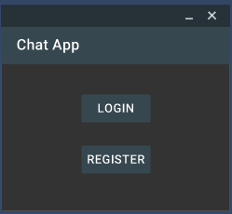

We made UI updates to the login process to make it easier on the eyes.

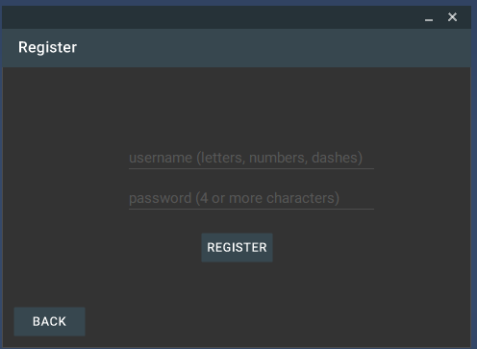

We continued the theme with our register page…

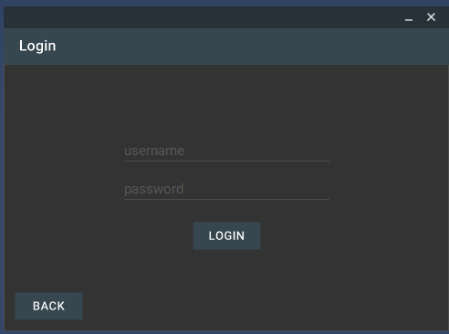

our login page…

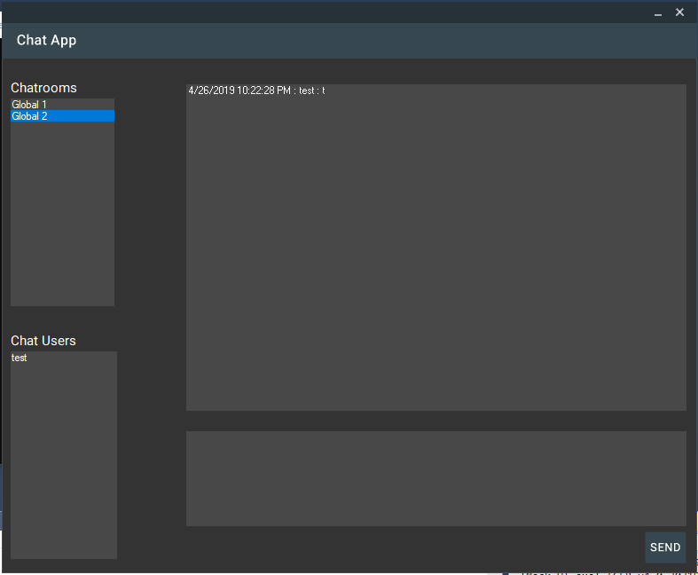

and our main chat window.

We did include themes to our program. Shown is our light and dark themes.

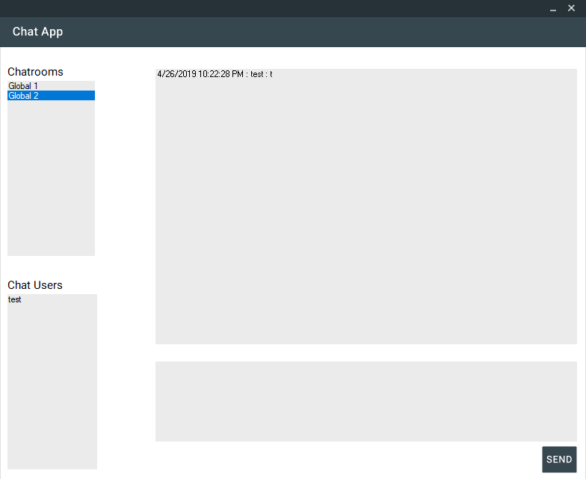

A screenshot of our light theme by itself.

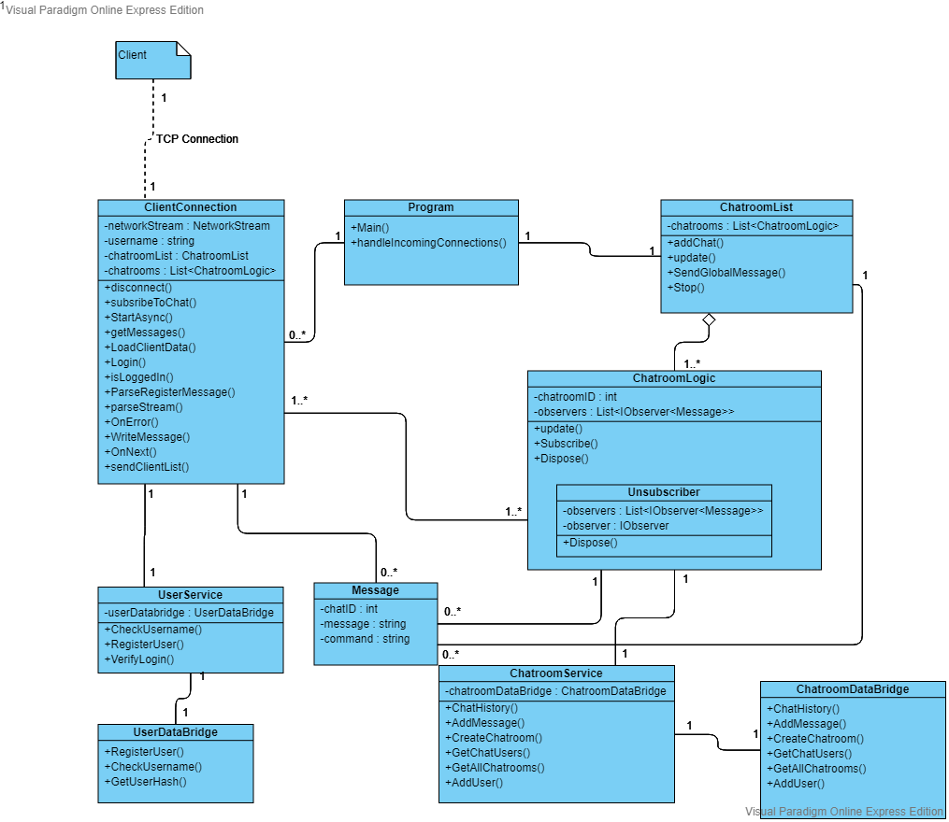

Our server class diagram for iteration 3

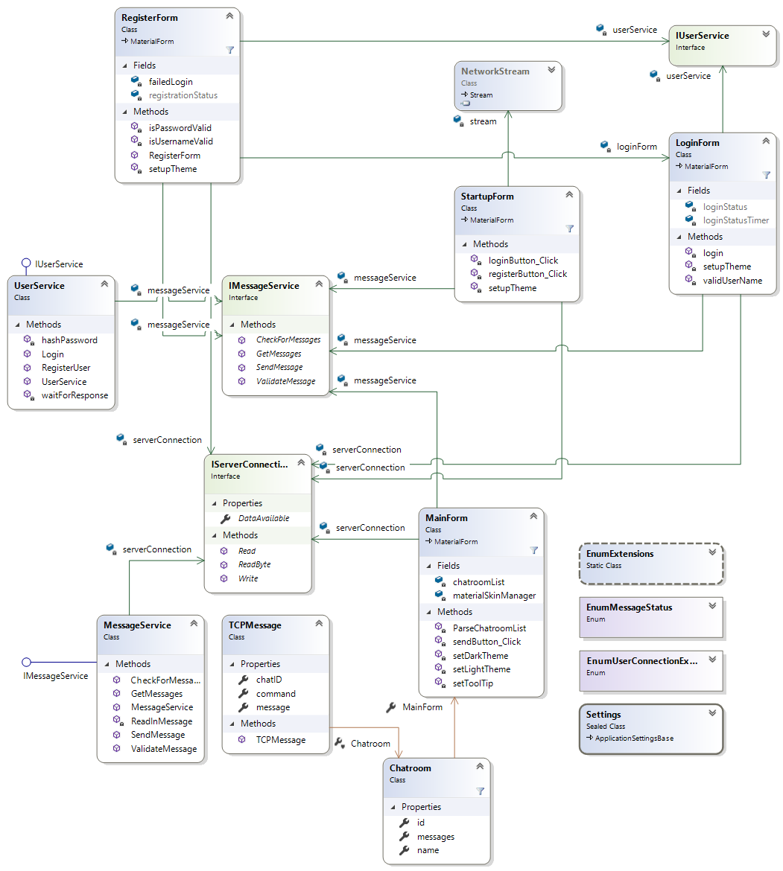

Our client class diagram for iteration 3.